|  |  |
| --- | --- |
|  | **What is your mobile number?** |
| **Problem Statement:**  These days Bechan Chacha is depressed because his crush gave him list of mobile number some of them are valid and some of them are invalid. Bechan Chacha has special power that he can pick his crush number only if he has valid set of mobile numbers. Help him to determine the valid numbers.  You are given a string "S" and you have to determine whether it is Valid mobile number or not. Mobile number is valid only if it is of length 10 , consists of numeric values and it shouldn't have prefix zeroes.  Input Format:  First line of input is T representing total number of test cases.  Next T line each representing "S" as described in in problem statement.  Output Format:  Print "YES" if it is valid mobile number else print "NO". Note: Quotes are for clarity.  Constraints:  1<= T <= 103  sum of string length <= 105  Sample Input 3  1234567890  0123456789  0123456.87  Sample Output YES  NO NO | |

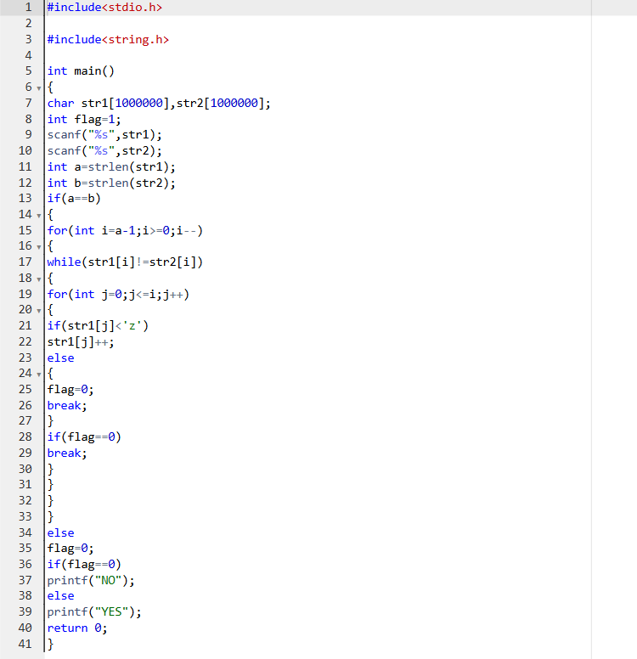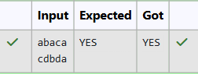

|  |  |
| --- | --- |
|  | **Alice and Strings** |
| **Problem Statement:**  Two strings A and B comprising of lower-case English letters are compatible if they are equal or can be made equal by following this step any number of times:   * Select a prefix from the string A (possibly empty), and increase the alphabetical value of all the characters in the prefix by the same valid amount. For example, if the string is xyz and we select the prefix xy then we can convert it to yx by increasing the alphabetical value by 1. But if we select the prefix xyz then we cannot increase the alphabetical value.   Your task is to determine if given strings A and B are compatible. Input format  First line: String A  Next line: String B  Output format  For each test case, print YES if string A can be converted to string B, otherwise print NO.  Constraints  1 ≤ len(A) ≤ 1000000  1 ≤ len(B) ≤ 1000000  Sample Input abaca  cdbda  Sample Output YES  Explanation  The string abaca can be converted to bcbda in one move and to cdbda in the next move. | |

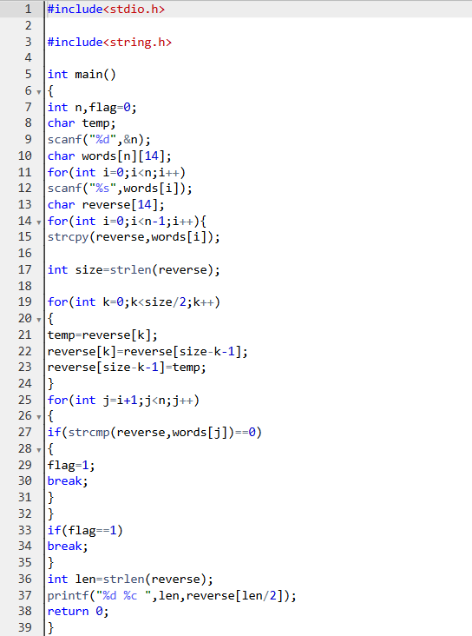

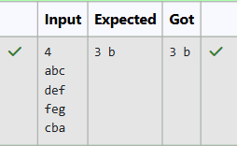

|  |  |
| --- | --- |
|  | **Pizza Confusion** |
| **Problem Statement:**  Joey loves to eat Pizza. But he is worried as the quality of pizza made by most of the restaurants is deteriorating. The last few pizzas ordered by him did not taste good :(. Joey is feeling extremely hungry and wants to eat pizza. But he is confused about the restaurant from wherehe should order. As always he asks Chandler for help.  Chandler suggests that Joey should give each restaurant some points, and then choose the restaurant having maximum points. If more than one restaurant has same points, Joey can choose the one with lexicographically smallest name.  Joey has assigned points to all the restaurants, but can't figure out which restaurant satisfies Chandler's criteria. Can you help him out?  Input Format:  First line has N, the total number of restaurants.  Next N lines contain Name of Restaurant and Points awarded by Joey, separated by a space.  Restaurant name has no spaces, all lowercase letters and will not be more than 20 characters.  Output Format:  Print the name of the restaurant that Joey should choose.  Constraints:  1 <= N <= 105  1 <= Points <= 106  Sample Input 3  Pizzeria 108  Dominos 145  Pizzapizza 49  Sample Output Dominos | |
|  | **Password** |
| **Problem Statement:**  Danny has a possible list of passwords of Manny's facebook account. All passwords length is odd. But Danny knows that Manny is a big fan of palindromes. So, his password and reverse of his password both should be in the list.  You have to print the length of Manny's password and it's middle character. Note: The solution will be unique.  Input Format  The first line of input contains the integer N, the number of possible passwords.  Each of the following N lines contains a single word, its length being an odd number greater than 2 and lesser than 14. All characters are lowercase letters of the English alphabet.  Output Format  The first and only line of output must contain the length of the correct password and its central letter.  Constraints 1 ≤ N ≤ 100  Sample Input 4  abc def feg cba  Sample Output 3 b | |

